User Guide to run Wikipedia Scorer for Mac

1. Move the folder containing WikipediaScorer onto the desktop.
2. Rename the folder on your desktop to *WikipediaScorer*
3. Go to spotlight search in the top right of your screen, and search Terminal.

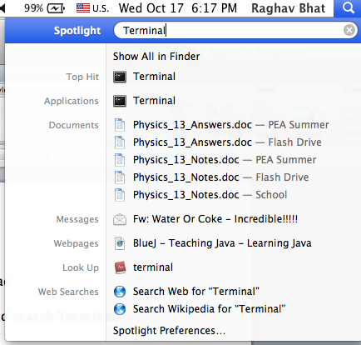

1. Click on the Application Terminal.
2. Once terminal is open, type:  
   cd Desktop  
   and press enter.
3. Then type:  
   cd WikipediaScorer  
   and press enter.
4. Type  
   mkdir bin  
   and press enter.
5. Type  
   cp info –R bin  
   and press enter.
6. Type  
   javac *.java –d bin  
   and press enter.
7. Type  
   cd bin  
   and press enter.
8. Now you have compiled the program. To run it, type  
   java Master *number_of_articles alphabet_size count_store_locgation prob_store_location*  
   where *number_of_articles* is a number, *alphabet_size* is a number, and *count_store_location* and *prob_store_location* are file names. For instance, you might type  
   java Master 100 1000 count.json probs.json  
   to run analysis of 100 articles, with an alphabet size of 1000, and store the results in the files counts.json and probs.json.
9. The results are saved in count_store_location and prob_store_location.